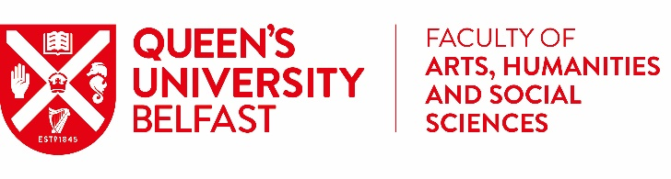**AHSS Mobility Awards**

**Academic Approval Form**  
**2024 - 2025**

Students applying for the [AHSS Mobility Awards](https://www.qub.ac.uk/about/Leadership-and-structure/Faculties-and-Schools/Arts-Humanities-and-Social-Sciences/AHSSSkillsDevelopment/GlobalMobility/) require an academic sponsor to support their application before it can be processed. Students may approach their Adviser of Studies, Personal Tutor, or Module Coordinator for this.

Please complete the below and submit with your application:

**Student Details: To be filled out by the applying student**

Student Name:

Student ID:

Details of activity that need financial support through the AHSS Mobility Awards:

Title of Activity:

Location:

Dates:

**Academic Approval Details: To be filled out by the approving academic**

Staff Name:

School:

Position:

Email Address:

I confirm that this activity will add value to the student’s degree, enhance their skills, and is relevant to their chosen career.

By completing this form, you are confirming that the above activity is not part of a School Led Cohort and therefore the above student meets the criteria to apply for funding.

YES  NO

**For more information or to ask a question, please contact** [**ahssabroad@qub.ac.uk**](mailto:ahssabroad@qub.ac.uk)